Create file in home directory(/Home/Demo.txt):

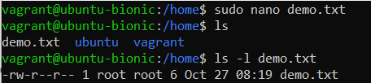

Change permission to the file:

